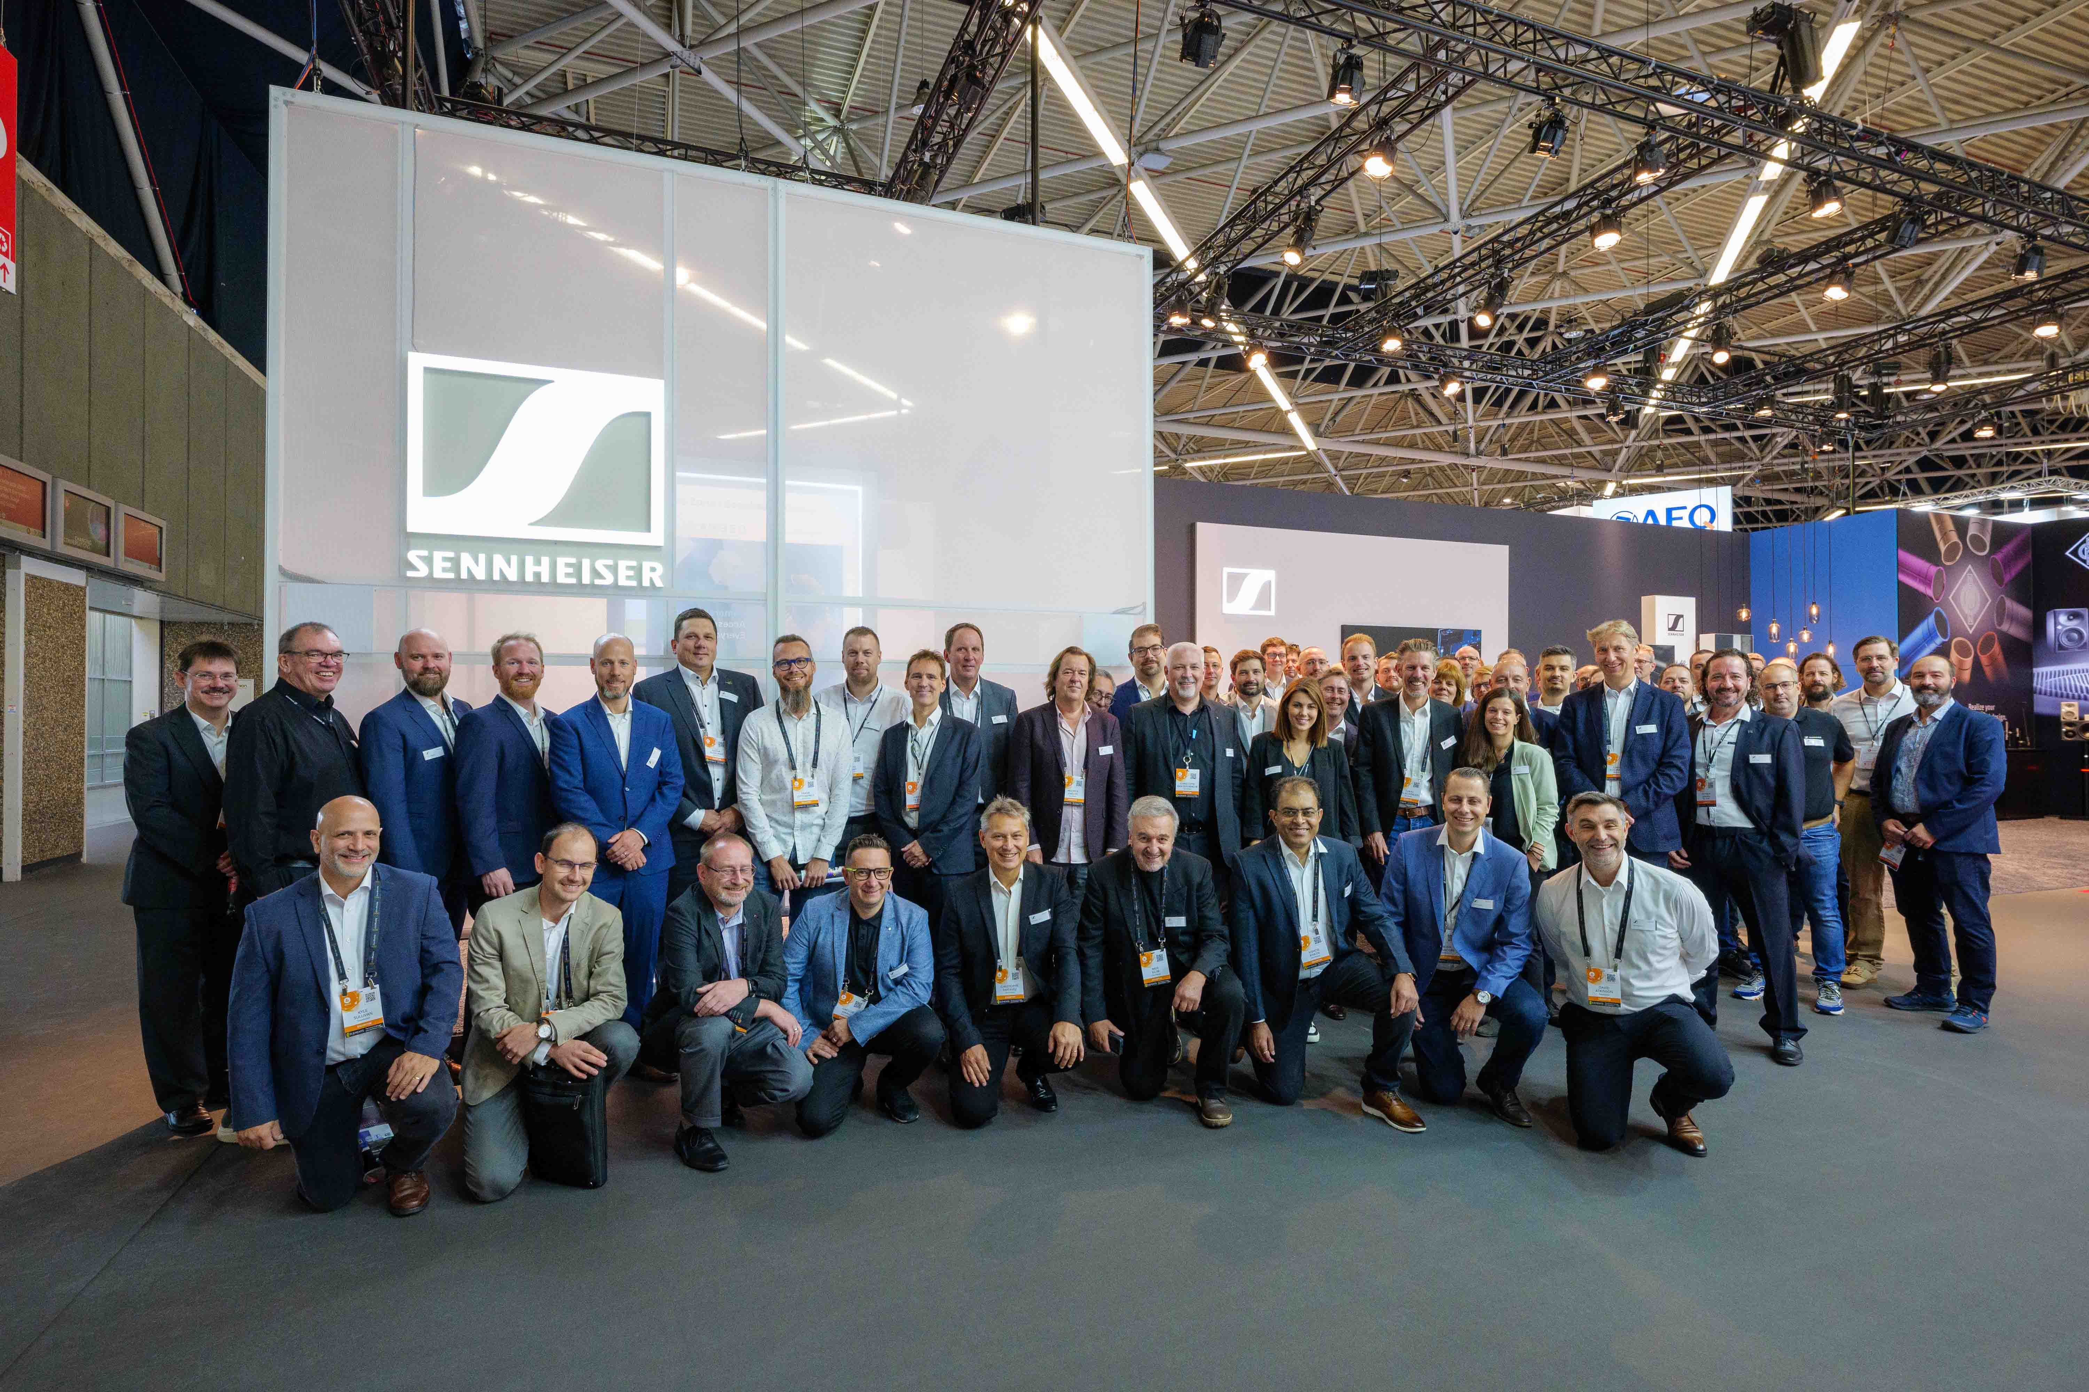

The Sennheiser Group at IBC 2024
Unveiling the Sennheiser WMAS ecosystem and introducing Merging hardware upgrades

Wedemark, 6 August 2024 – Welcoming audio and broadcasting experts from across the globe, the Sennheiser Group with its brands Sennheiser, Neumann, Dear Reality and Merging Technologies will introduce exciting new products and platforms at IBC 2024 in Amsterdam. At stand 8D50 in the Audio Hall, there is plenty to explore between the AMBEO Immersive Zone and the WMAS Discovery Area.

WMAS Discovery Area
In what is probably the most anticipated presentation this year, Sennheiser will unveil the world’s first wideband, bidirectional wireless ecosystem based on WMAS technology (Wireless Multichannel Audio Systems). Guests are invited to experience the system’s combined mic/IEM bodypacks and revolutionary base station, while the Sennheiser RF experts are happy to answer any questions on this ground-breaking technology.

Neumann and Merging Broadcast Suite
Stepping into the “interior” of a typical OB van, visitors can experience the world of Neumann and Merging broadcast products for audio control, mixing, editing, and monitoring. Neumann will showcase DSP-powered KH monitors and NDH studio headphones as well as the MT 48 with the new Monitor Mission, which transforms the unit into an immersive audio interface and monitor controller. Merging will present its renowned Pyramix DAW software and Anubis interface, including dedicated Missions (Commentary, Monitor, Music, and Venue) that allow the device to be customized for these typical use cases. On top of that, Merging will also unveil upcoming upgrades with additional network options.

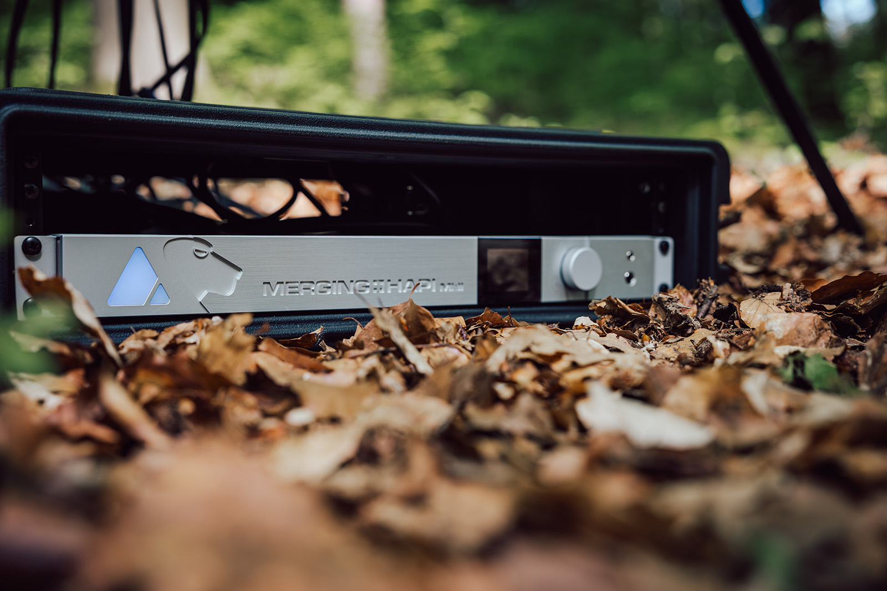 | At IBC, Merging will show new hardware upgrades

Sennheiser Pro Audio Workbench
Sennheiser has its broadcast customers covered for ENG and studio applications: The camera-mount EW-DP mic systems are ideal for on-site interviews and news coverage, while the rack-mount Digital 6000 and EW-DX wireless audio solutions are ideal for shows and other live or broadcast studio formats.

The rugged MKH 8000 RF condenser microphone series for sophisticated audio capture will also be on show, as will be Sennheiser’s updated broadcast headset portfolio, which covers the needs of commentators, broadcast engineers and camerapeople alike.

The Sennheiser MKH 8030 and MKH 8060 RF condenser microphones in an MS stereo set-up

The AMBEO Immersive Zone
Last but not least, the large AMBEO Immersive Zone, powered by a 5.1.4 Neumann monitor set-up and a Dear Reality headphone station, welcomes guests to discover interoperable spatial audio offerings.
- Immersive audio capture
Compare immersive audio material recorded using an AMBEO Cube with MKH 800 TWIN microphones, with the MKH 8030 in M/S stereo and double M/S stereo, and with the AMBEO VR mic
- AMBEO two-channel spatial audio for live
Automatically create an enhanced stereo mix with this plug-in for the Merging Anubis
- Cinematic stereo audio
Discover AMBEO two-channel spatial audio and compare it to standard stereo audio
- ST 2110 and AES 67 real-time networking
- Neumann MA1 Monitor Alignment
Experience the powerful impact of proper studio monitor alignment with the MA 1. Listen to sound samples and discover how an alignment can significantly enhance your audio results
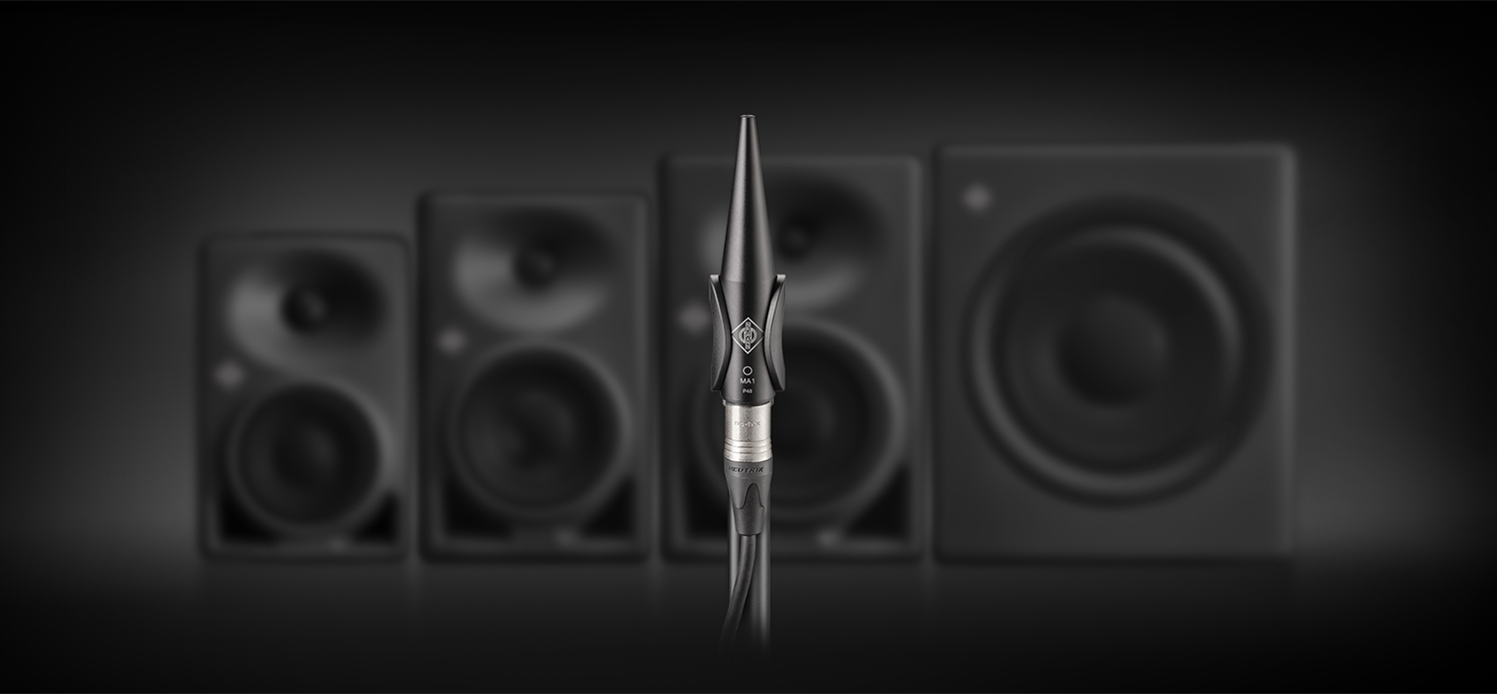
- Immersive Mixing on Headphones
Dear Reality’s dedicated headphone listening space invites visitors to experience the dearVR PRO 2 spatializer for immersive productions. Together with the dearVR MONITOR plugin, users can monitor multichannel loudspeaker formats up to 9.1.6 via stereo headphones

To best accommodate visitor interest, there is no fixed demo schedule this year, rather stand guests are encouraged to ask for the presentation of their choice.

Visit the Sennheiser Group at IBC, RAI Amsterdam, 13 to 16 September, Hall 8, Stand D50.

(Ends)

The high-resolution images accompanying this media release can be downloaded here.

About the Sennheiser Group
Building the future of audio and creating unique sound experiences for our customers - this is the aspiration that unites the employees of the Sennheiser Group worldwide. The independent family-owned company Sennheiser was founded in 1945. Today, it is managed in the third generation by Dr. Andreas Sennheiser and Daniel Sennheiser, and is one of the leading manufacturers in the field of professional audio technology.
sennheiser.com | neumann.com | dear-reality.com | merging.com

